LiftHub — Requirements Document
AiLab Intern Pre-Assignment · Phase 1 · v1.1, revised after Review Checkpoint 1
Author: Foster Brown · July 2026
“LiftHub” is a working title — rename freely.

1. Overview & Purpose
One-liner: A fitness hub where admin-verified trainers publish guides — workout programs, nutrition, gym picks — and members adapt those programs to their own equipment and schedule with AI, then get their questions answered by real professionals.
The problem. Fitness advice online is abundant and untrustworthy at the same time. Programs are written for someone else's equipment, schedule, and experience level; nutrition content ranges from solid to dangerous with no way to tell which is which; and the people who actually know — experienced trainers and lifters — answer the same questions over and over in DMs and gym-floor conversations, where the answers help one person once and then vanish.
The solution. One hub with a quality gate. Trainers — verified by admins with real gym experience — publish guides across categories (programs, nutrition, gym picks, recovery). Members do three things with a guide: read it, personalize it (the app asks an LLM to adapt the program to their equipment, available days, and level, returned as a structured plan), and ask questions that trainers answer in a public Q&A, so every answer accumulates instead of evaporating.
Why this app. I decided to create this app because I've been involved in the fitness industry for many years, and I've seen countless people struggle with where to begin when they first start going to the gym — just like I did. I know how overwhelming it can feel without the right guidance. Fitness and health are something I'm truly passionate about, so creating an app that helps beginners build confidence and achieve their goals is something that means a lot to me personally.

2. Target Users
User | Role in app | What they want
People who train, or want to start | member (default) | Programs that fit their equipment and schedule, plus trustworthy answers
Trainers, coaches, experienced lifters | trainer | Publish advice once, build a reputation, answer questions where everyone benefits
Experienced gym hands running the community | admin | Verify who is qualified to publish, keep content quality and safety up, manage accounts

3. Features & Priorities
Priority | Feature | Notes
P0 | Auth: sign-up / login / logout | Supabase Auth, email + password
P0 | Three roles, default on sign-up | member assigned automatically; role stored on a profiles row
P0 | Role-based access control | Routes gated in Next.js middleware; UI elements shown/hidden per role
P0 | Row Level Security | Per-role and per-owner rules enforced in the database, not just the UI (e.g. trainers can update only their own guides; members read only published rows)
P0 | Guide CRUD | Trainers create, edit, delete their own guides; draft/published status with publish and unpublish
P0 | Browse & filter | Signed-in users browse published guides, filter by category: programs, nutrition, gym picks, recovery
P0 | Guide page with markdown rendering | Guide bodies are markdown, rendered as formatted content client-side
P0 | Personalize this program (LLM feature) | Member sets equipment, days/week, and level; server-side API route sends the guide + constraints to the model; response is strict JSON {day, exercises: [{name, sets, reps}], notes}; rendered as plan cards; regenerate button. The latest plan per user per guide is saved and reloads on return — an append-only plans table that also powers the rate limit
P0 | Q&A on guides | Members ask questions on published guides; trainer and admin replies carry a role badge, snapshotted at posting time — this is the consulting core of the app
P0 | Admin user management | List users, change any user's role (member → trainer is the verification step), delete accounts
P0 | Responsive UI | Tailwind; usable on a phone — where people actually are at the gym
P0 | Deployed & public | Vercel, auto-deploy from GitHub main
P1 | Generation rate limit | Per-user daily cap on LLM calls (cost control), counted from the plans table
P1 | Loading & error states | Especially around the LLM call, which is slow and can fail
P1 | Saved training preferences | Profile stores equipment/days/level and pre-fills the personalize inputs
P1 | Title search
P2 | Streaming generation | Plan appears as it is generated
P2 | Role-change audit log | Who changed whose role, and when
P2 | “Ask this guide” (RAG) | Embeddings + vector search over guide content
P2 | Images in guides | Form photos and gym shots via Supabase Storage upload
P2 | Tests | Focused on permission logic
P0 is the MVP; P2 items are attempted only once P0–P1 are solid.

4. Roles & Permissions
Role | Can | Cannot
member (default) | Read published guides · personalize programs · ask questions on guides · edit own profile | See drafts · create or edit guides · access trainer/admin areas
trainer | Everything a member can · create guides · edit, publish, and delete their own guides · answer questions with a trainer badge | Edit other trainers' guides · manage users or change roles
admin | Everything a trainer can · edit or unpublish any guide · view user list · change any user's role · delete accounts | —
Notes.
- Only admins change roles, at any time after sign-up. Promoting a member to trainer is the app's credential-verification step — the role system is the quality gate, not decoration.
- Trainers own their guides. Unlike shared course notes, fitness advice carries the author's professional reputation, so editing is per-owner — which also makes the RLS story stronger: policies check auth.uid() = author_id, not just role.
- Admins can edit or unpublish anything: that is the moderation path for content that is wrong or unsafe (see §7).
- Q&A moderation mirrors the guide ownership model: authors can delete their own posts (removing a question removes its answers), and admins can delete any post. No post editing in v1 — delete and repost. Each post snapshots the author’s role at posting time, so trainer and admin badges stay accurate even if a role changes later.
- Permissions are enforced in three layers: UI (hide what you can't use), middleware (block routes you can't visit), and RLS (the database refuses what the first two layers miss). Only the last one is a real security boundary; the first two are UX.

5. Screens & Wireframes
Wireframes are lo-fi drafts produced with AI tooling from the screen definitions in this section. Access-tag colors on the frames: public (gray) · signed-in (blue, any role) · trainer and admin (purple) · admin only (red). Green/amber pills mark a guide's published/draft status, not a role.
1. Login / Sign-up /login, /signup
Access: Public · Key elements: Email and password forms; new accounts start as member.
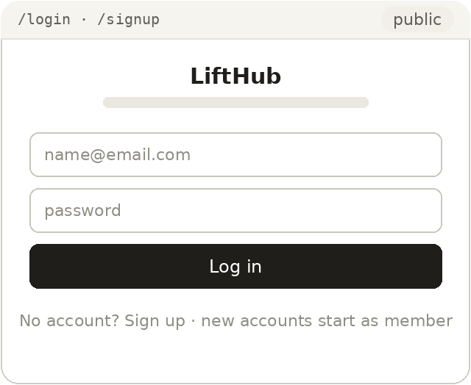
2. Browse /
Access: Signed-in · Key elements: Category filter and guide cards (title, category, author, updated); Dashboard and Admin nav items appear only for eligible roles.
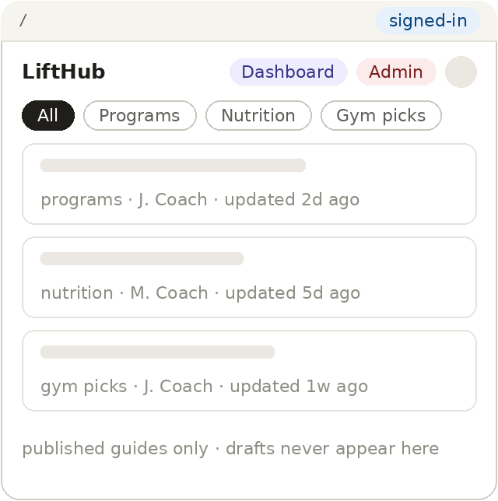
3. Guide detail /guides/[id]
Access: Signed-in for published guides; trainers and admins can also open drafts · Key elements: Rendered guide, personalize inputs (equipment, days/week, level), Personalize this program with plan cards and regenerate, Q&A thread with badged trainer answers; Edit visible to the owning trainer and admins.
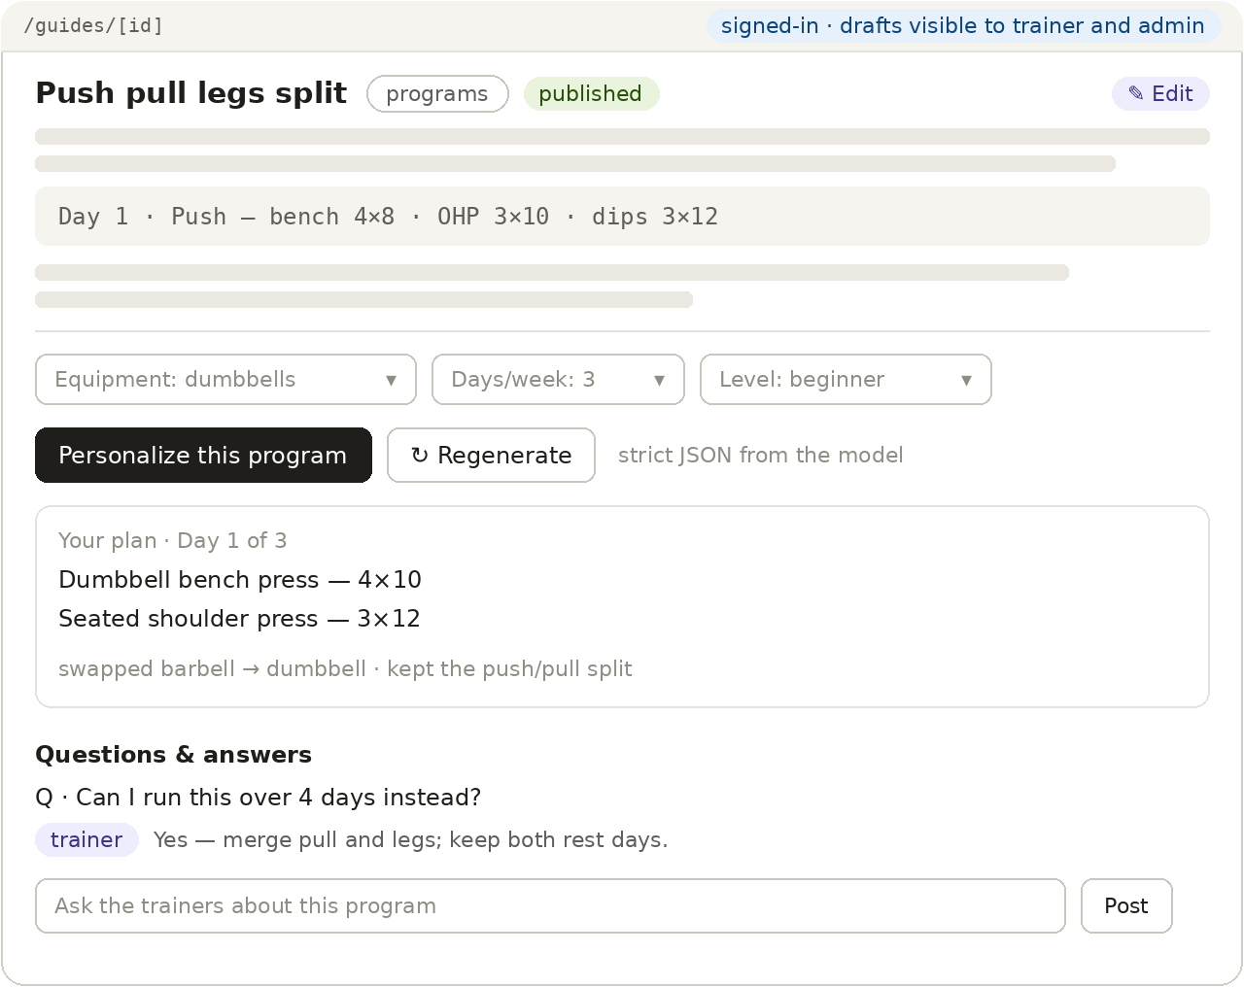
4. Trainer dashboard /dashboard
Access: Trainer and admin · Key elements: The trainer's own guides including drafts, publish status per row, New guide; admins see all guides.
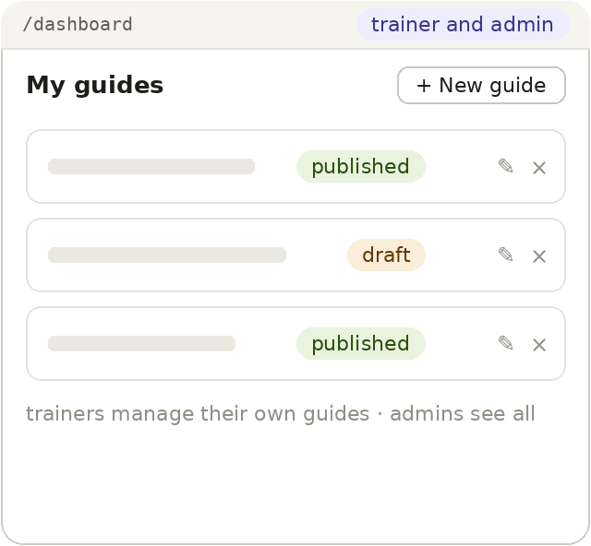
5. Guide editor /guides/new, /guides/[id]/edit
Access: Trainer (own guides) and admin · Key elements: Title, category select, markdown body editor with live preview, Save draft / Publish.
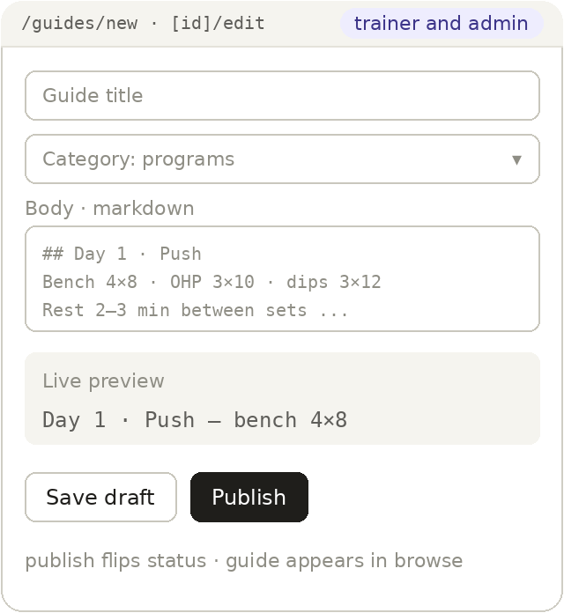
6. User management /admin/users
Access: Admin only · Key elements: User list with a role dropdown per account (writes profiles.role) and account deletion; promoting member → trainer is the credential-verification step.
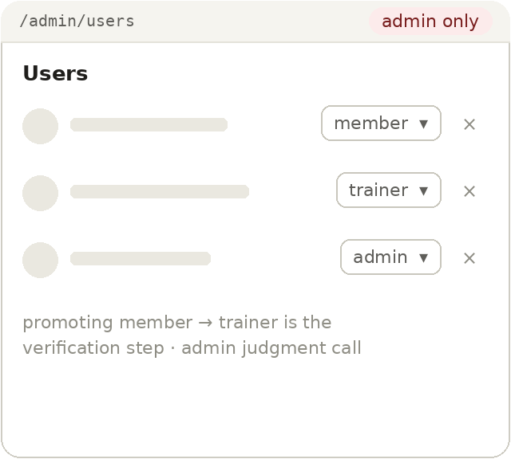
7. Profile /profile
Access: Signed-in · Key elements: Display name; role shown read-only — only admins change roles; saved training preferences (P1) pre-fill the personalize inputs.
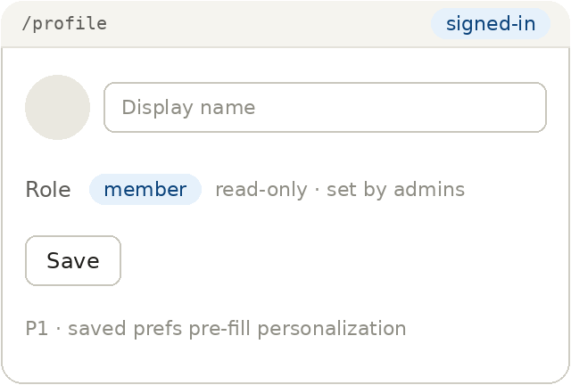

6. Technology Choices & Rationale
The stack is set by the brief; what follows is why each piece fits this app.
Next.js (App Router). One repo for UI and API. Role checks live in middleware.ts for /dashboard, /admin, and editor routes. The LLM call happens in a server-side route handler, so the API key never reaches the browser.
Supabase. Auth, Postgres, and RLS in one service. The permission model maps naturally onto it: a profiles.role column plus auth.uid() inside RLS policies gives per-role and per-owner rules — members read only published rows, trainers update only rows where they are the author, only admins may update role.
Anthropic API. The personalize feature sends the guide content plus the member's equipment, days/week, and level to a small, fast model tier and requests a strict-JSON plan. Per-call cost is small, and a daily per-user cap (P1) keeps total spend predictable. The prompt is constrained per §7.
Markdown rendering. Guide bodies are markdown rendered client-side (e.g. react-markdown), which handles headings, exercise lists, and tables without a custom editor.
Tailwind CSS. Utility classes keep responsive layouts fast to build and easy for AI tools to generate consistently.
Vercel + GitHub. Push-to-deploy from main; small per-feature commits with meaningful messages, per the brief.
Cursor / Claude Code. Used at every phase. Auth and RLS code gets a line-by-line review before commit, per the assignment's AI rules.

7. Content & Safety Notes
Fitness and nutrition content touches health, so the app takes three inexpensive precautions. First, a persistent disclaimer on guide and plan pages: content is general fitness information, not medical or clinical advice. Second, the personalization prompt instructs the model to stay within general training guidance — no medical, injury-specific, or clinical dietary claims — and to recommend consulting a professional when a request mentions pain, injury, or a health condition. Third, moderation is built into the role system: admins can unpublish any guide and delete any Q&A post, which is the removal path for unsafe or misleading content.

8. Out of Scope (v1)
Calorie/macro tracking, progress logging, wearable integrations, session booking or payments between members and trainers, direct messages or real-time chat, a plan-history page (v1 shows only the latest saved plan per guide), and native mobile apps. Two weeks buys one entity type done properly, not five done badly.

9. Open Questions for Review
- Trainers currently edit only their own guides (professional-content model). Is co-authoring between trainers worth supporting?
- Q&A is a flat, single-level thread per guide. Are threaded replies worth the v1 complexity?
- Personalization is open to all signed-in roles under the same rate limit. Should it be member-focused instead?
- Reading requires sign-in, which keeps the member role meaningful. Is a public read-only landing page preferred instead?

